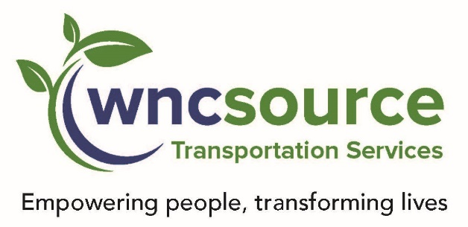

* **Welcome**
* Call to Order **Noah Rose -**10:00am
* Public Comments
* Approve Minutes from February 2024 Meeting-**Noah Rose, Board Chair**
* Transportation Directors Report – **Tim Camp / Bonnie Wilson**
* Open floor for **TAB Members** to share news and information related to their organization.
* Next Meeting – 10:00am August 15, 2024
* Motion to Close - **Victoria Cortes**

**TAB Officers 2024**

**Noah Henderson – Chair**

**Victoria Cortes – Vice Chair**

**Kim Hall – Secretary**

### Date:

### Thursday May 16, 2024

### Time:

**10:00 AM**

Where:

**Via Google Meet**

# WNCSource Transportation

# Transportation Advisory Board (TAB)

*“Thank you for your time today and thank you for your service on the WNCSource Transportation, Transportation Advisory Board.”*

## AGENDA May 2024